Git
* Keep track of various versions of files
* Resolve conflicts
* Allows Developers to share code across multiple Team members
* Allows to merge multiple versions of file into single final version.
* Allows to lock files

There are two types of Versions controlling systems
1) Centralized version control system
The code repository is centralized, anything happens to code repository makes entire team sitting idle.
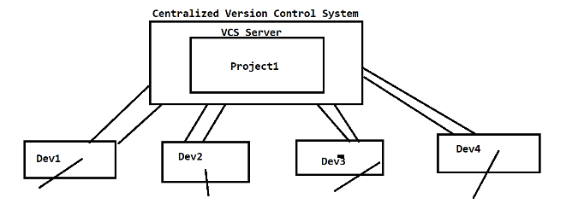
2) Distributed Version Control System
We will have 1 remote /central repository and multiple repositories as cloned copies of central Repository. If anything happens to central repository, does not disturb the workflow because our code will be saved in local repository.

